
Jenkins challenge – 02
- Create a Declarative Jenkins parameterized pipeline for simplecustomerapp.

- Create New Pipeline Job
- Open Jenkins dashboard
- Click New Item
- Enter job name: SIMPLECUSTOMERAPP-parameter_job
- Select Pipeline
- Click OK
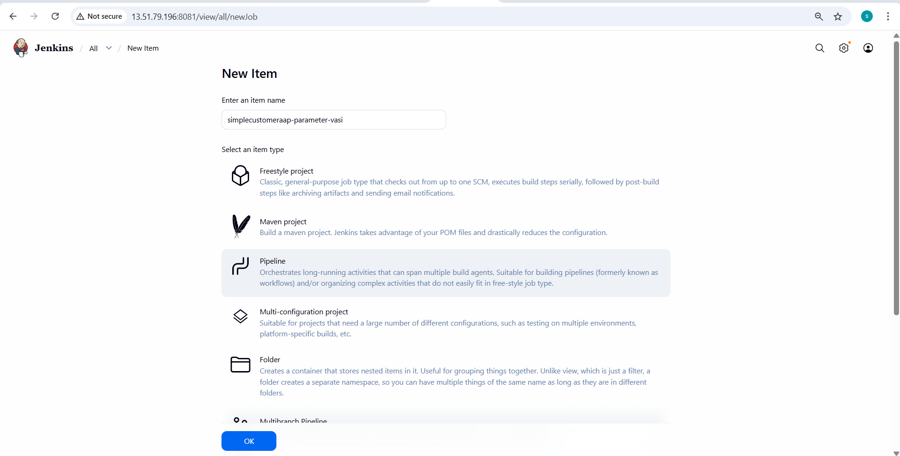
- Enable Parameters
- Go to Configure
- Under General, enable This project is parameterized
- Add Choice Parameter (ENV)
- Click Add Parameter
- Select Choice Parameter
- Name: ENV
- Choices:
- dev
- qa
- Description: Target environment
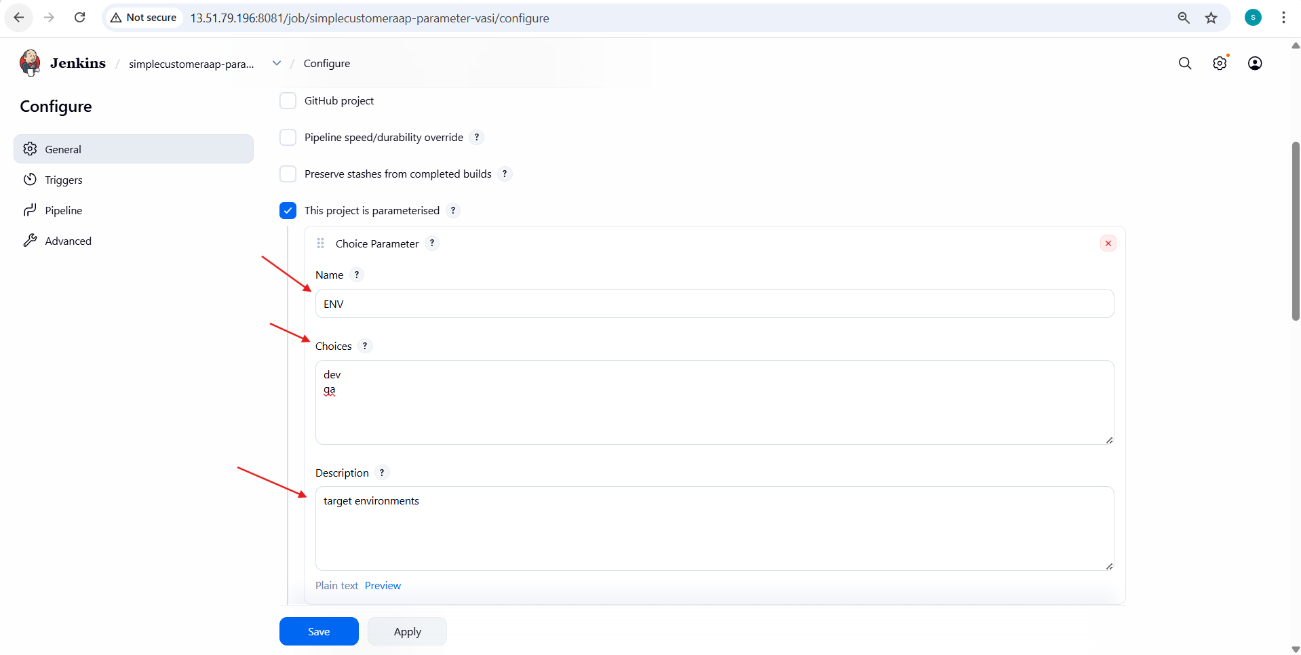
- Configure Pipeline Script
- Go to Pipeline section
- Select Definition → Pipeline script
- Paste the pipeline code containing:
  - parameters block
  - BRANCH_NAME (string parameter)
  - ENV (choice parameter)
  - Environment variables
  - Stages: Checkout, Build, Test, Package
  - Post actions (success & failure)

- Define Parameters in Script
- Add parameters inside pipeline:
  - BRANCH_NAME with default master
  - ENV with choices dev, qa
Configure Environment Variables
- Set:
  - APP_NAME
  - MAVEN_HOME
  - Update PATH with Maven binaries
- Checkout Source Code
- Use Git repository URL
- Checkout branch using:
- ${params.BRANCH_NAME}

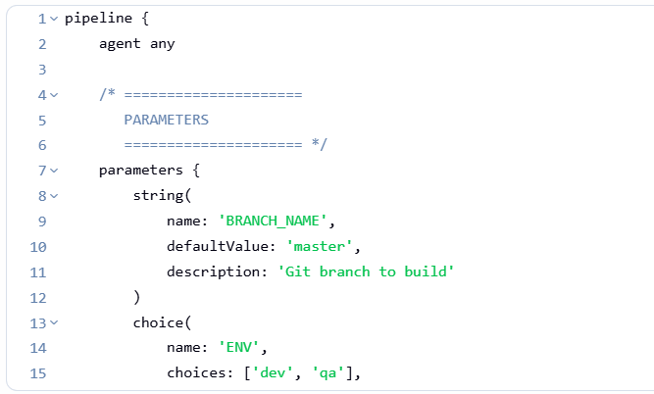
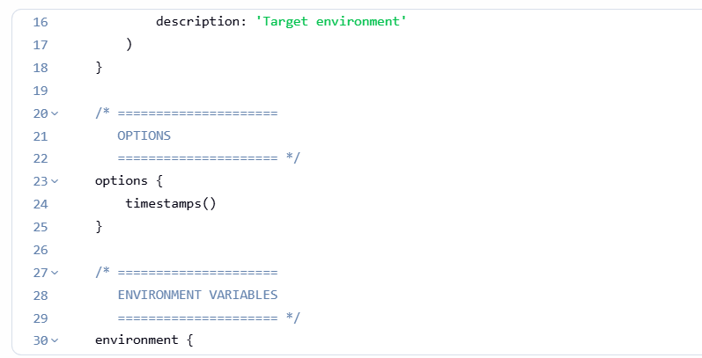
- Build Stage
- Run Maven command:
mvn clean compile
- Test Stage
- Execute:
- mvn test

- Package Stage
- Execute:
- mvn package

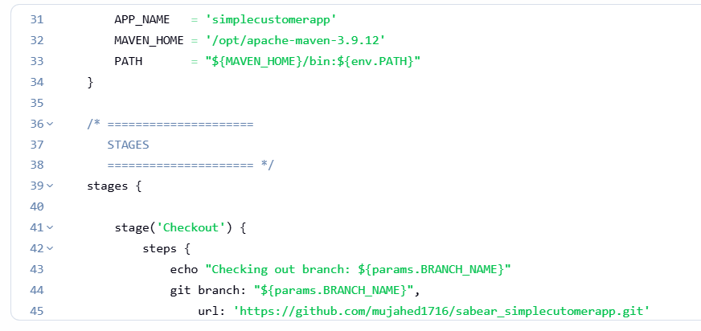
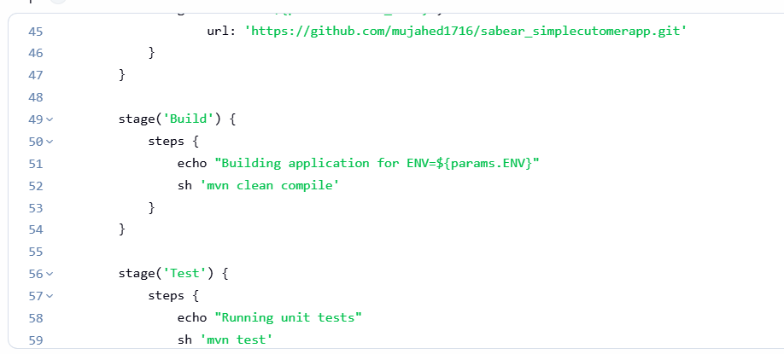
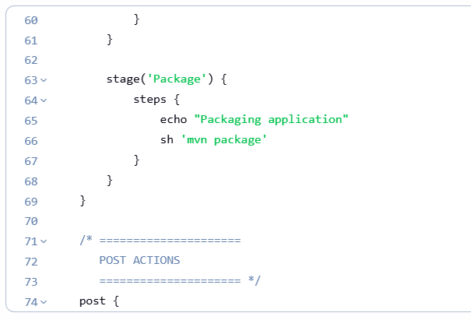
- Configure Post Actions
- On success:
  - Print success message
  - Include selected environment
- On failure:
  - Print failure message
Mark build as failed
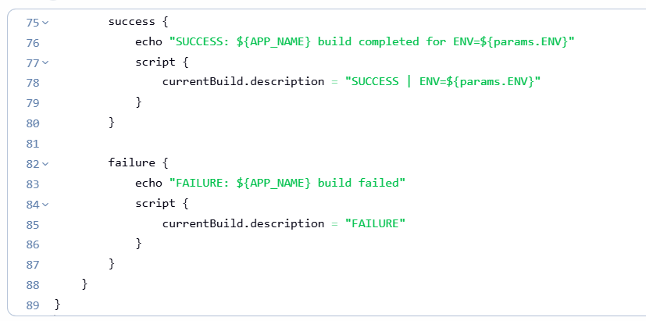
- Trigger Build with Parameters
- Click Build with Parameters
- Select:
  - BRANCH_NAME (default: master)
  - ENV → dev or qa
Click Build

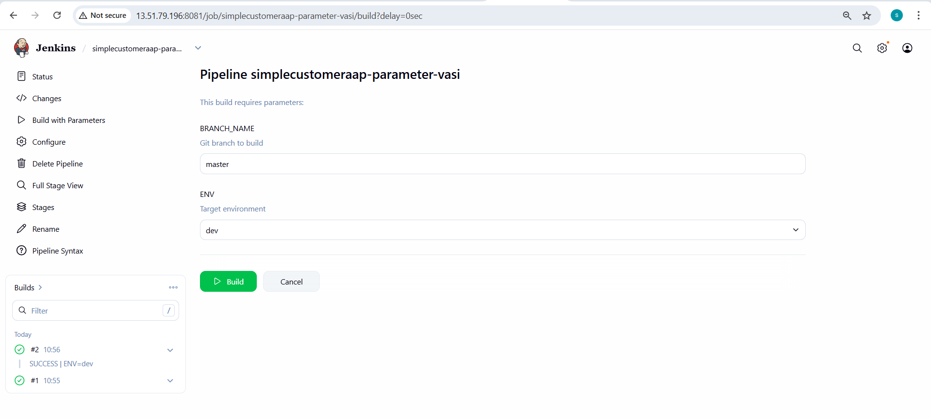
- Verify Stage View
- Open Stage View
- Verify stages:
  - Checkout
  - Build
  - Test
  - Package
  - Post Actions
- Confirm build status is SUCCESS

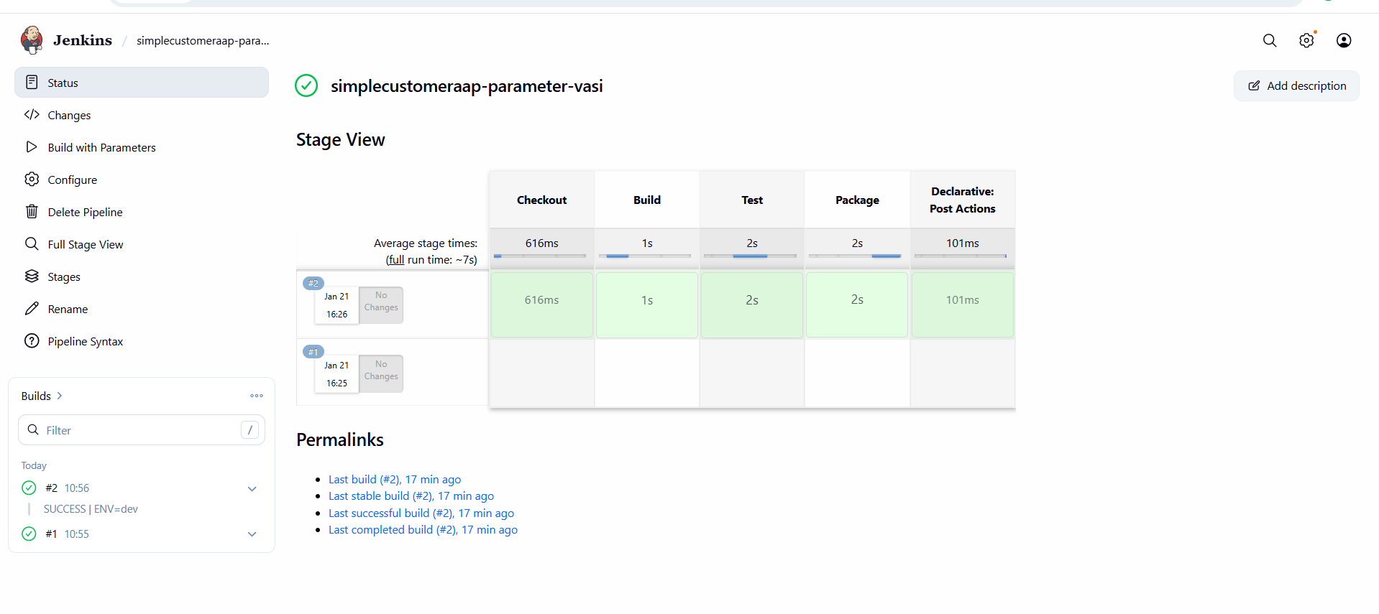
- Verify Build Description
- Open build details
- Confirm description shows:
SUCCESS | ENV=dev (or qa)

